**Requirement Gathering and Analysis Phase**

**Data Flow Diagram & User Stories**

|  |  |
| --- | --- |
| Date | 24 June 2025 |
| Team ID | LTVIP2025TMID59418 |
| Project Name | House Hunt:Finding your perfect rental home |
| Maximum Marks | 4 Marks |

**Data Flow Diagrams:**

A Data Flow Diagram (DFD) is a traditional visual representation of the information flows within a system. A neat and clear DFD can depict the right amount of the system requirement graphically. It shows how data enters and leaves the system, what changes the information, and where data is stored.

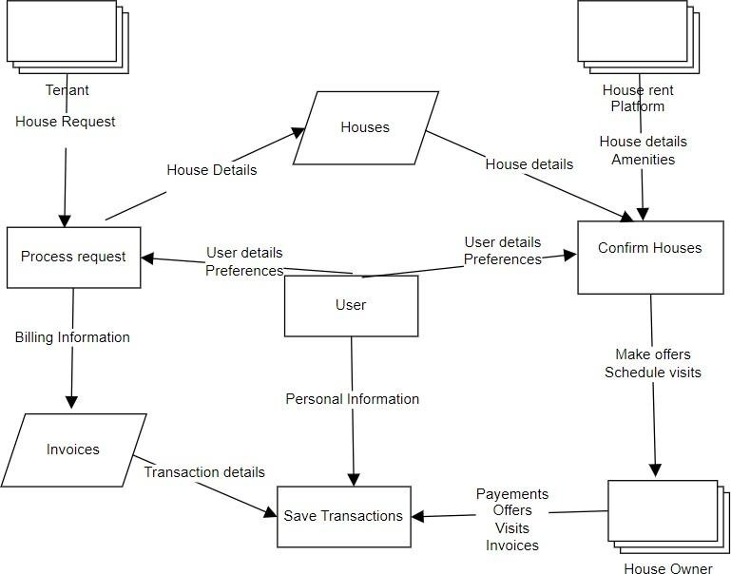

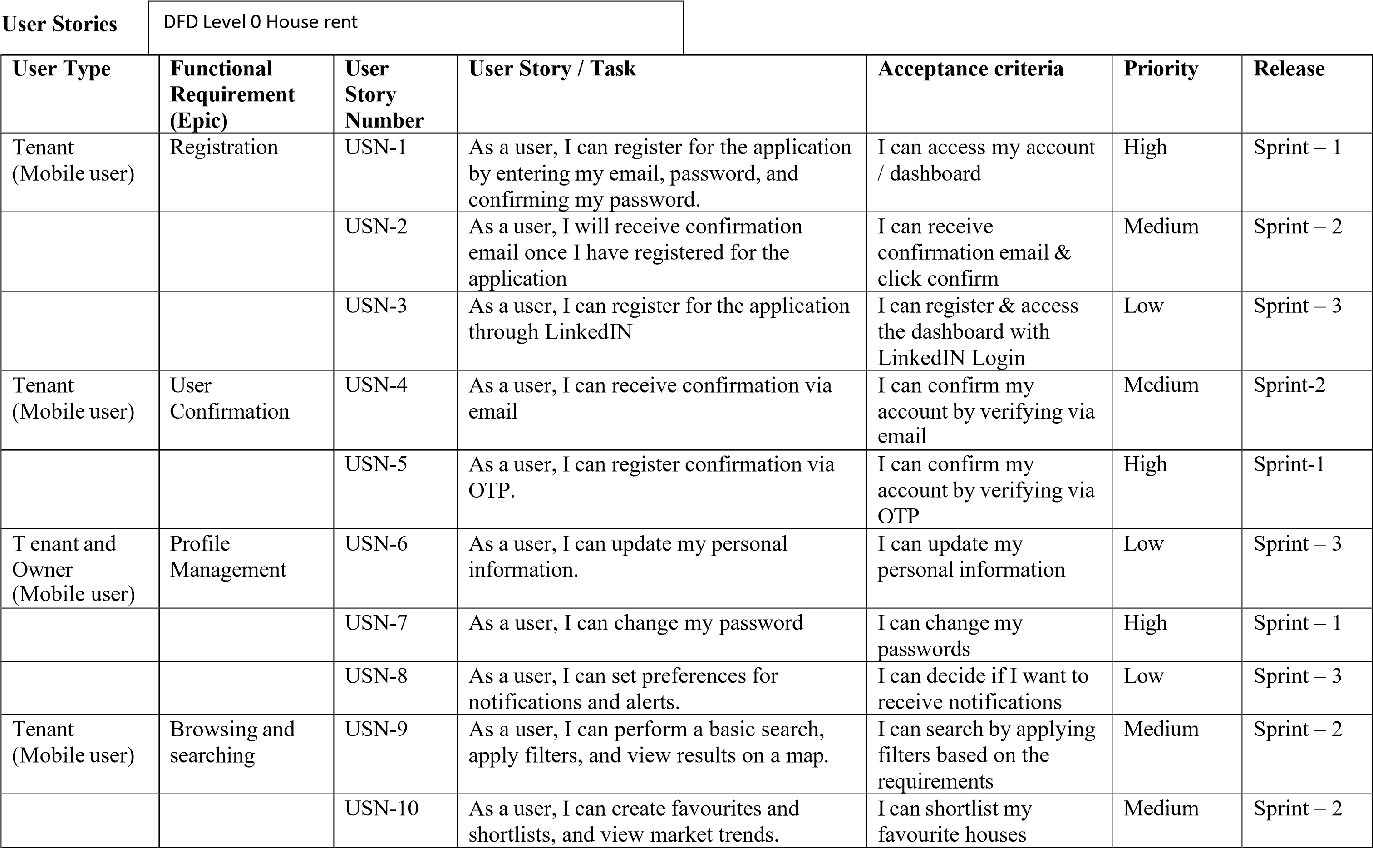

|  |  |  |  |  |  |  |
| --- | --- | --- | --- | --- | --- | --- |
| **User Type** | **Functional**  **Requirement**  **(Epic)** | **User**  **Story**  **Number** | **User Story / Task** | **Acceptance criteria** | **Priority** | **Release** |
|  |  | USN-11 | As a user, I can view nearby amenities. | I can verify and enquire about nearby amenities | Low | Sprint - 3 |
| Tenant and  Owner  (Mobile user) Admin (Web  user) | Communication | USN-12 | As a user, I can use messaging and schedule appointments. | I can schedule house visits | High | sprint – 1 |
|  |  | USN-13 | As a user, I can share documents and receive transaction updates. | I can manage Invoices and transaction details | Low | Sprint – 3 |
| Owner  (Mobile user) | Property Listing | USN-14 | As a user, I can upload photos and videos, and add property features and amenities. | I can upload photos of my property | Medium | Sprint – 2 |
|  |  | USN-15 | As a user, I can access legal and disclosure information, and negotiate offers. | I can access legal information and negotiate offers | High | Sprint – 1 |